Week 5 & 6 Blog - Post
Professor: Dr. Catherine Williams

Data Presentation and Visualization
Term Project Milestone 3 (Week 4&5)

Author: KARTHIKEYAN CHELLAMUTHU
Due Date: 07/17/2022

Introduction

The visualization executive summary report was built for pre-requisite to review internally and start with external communication. This is to provide the facts about the airline travel is safe and there is no adverse impact because of negative publicity made by media that it is dangerous to travel. Especially due to COVID lot of travel industries airline booking and subsequent cancellations are causing airline partners owners the constant headache of losing business.

Abstract

Content published in this executive summary was targeted to the senior leaders, especially for the leaders who care about the portrayal of the industry and their airline specifically. Since we planned for the executives and external communication we wanted to make sure data used being ethical and sharing information is not misleading. This presentation will set the tone and recommendation for how the media is addressed going forward with the information and facts that need to be shared. The executive summary contains the information of the historical data of worldwide airlines and fatal incidents, fatalities happened specific to airlines and in the year, also captured financial data to show that there is not impact on overall profit and public demand to airline travel.

Blog Post: https://karthikchellamuthu.blogspot.com/

How safe to travel in Airline?
by Karthikeyan Chellamuthu on July 16, 2022



When traveling, it is important to keep safety in mind. Safety should be a top priority during travel, and airline travel safety is an important aspect of any trip that requires travel flying abroad. Air travel is one of the safest modes of transportation, but there are steps that can be taken by individuals to further ensure health and safety during any trip. To ensure the safety of passengers, airlines and passengers traveling on airlines are subject to many travel restrictions. To have the best trip possible, knowing what these restrictions are and preparing to fly will help ease the stress of travel.

Figure1 below shows the airlines accidents are ONLY 0.07% of motor vehicles, Fatality Rate of Airlines for Year
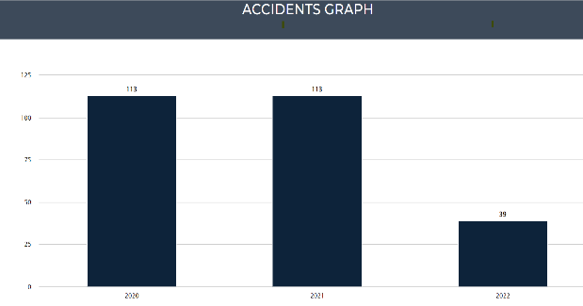
2022. This is much lesser than Roadways Based on these number of accidents Air travel is one of the safest form of transport. Hence we this is an indication that improved safety for a main purpose of this blog was to provide important facts about Airline travels are safe.

Figure 2: Considerably very less in 20th century (2000-2014) compared to prior years of 19th century (1985-1999). The graph shown in figure 2 shows the number of incidents and fatal accidents over two time periods, the 1985-99-time period and the 2000-14-time period. From the graph, we see the number of air traffic fatal accidents has been declined.
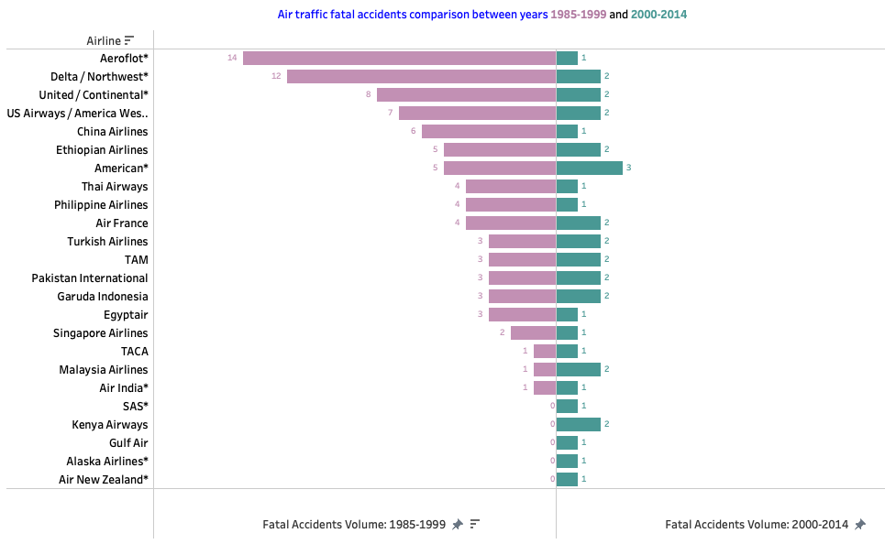

Figure 3: Below figure explains fatalities caused by air traffic accidents are gone down and its very less in the 20th century (2000-2014) compared to prior years of 19th century (1985-1999) with visuals.
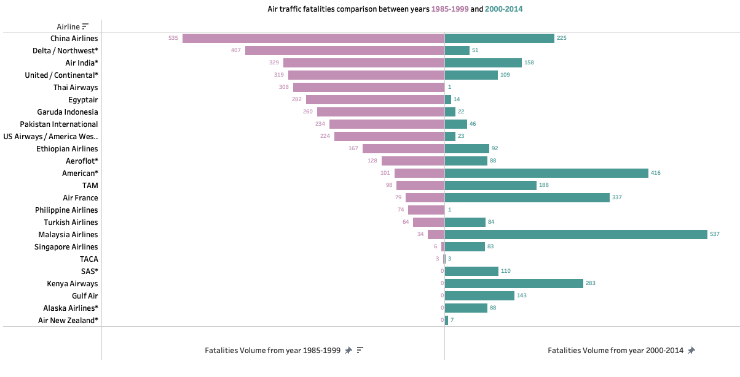
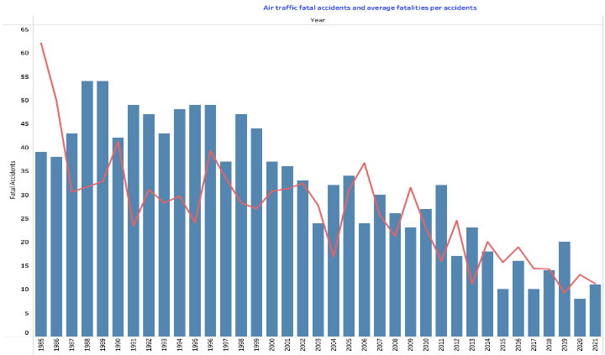
Figure 4: Below figure display the fatalities caused by air traffic accidents are gone down and its very less in the 20th century (2000-2014) compared to prior years of 19th century (1985-1999) with visuals. Comparing the charts, airline reported accidents and fatalities around the world were way less compared to total ground accidents and fatalities reported.

Figure 5: In this figure shows how to prove and to identify the trend direction of average to support and resistance levels.to the executives that airline fatal accidents trend is going down, this chart shows the trend of fatal accidents of airlines from 1985 to 2021 and it clearly shows the trend is downgraded and shown the 5-years moving average and its trend shows the going down in recent years.
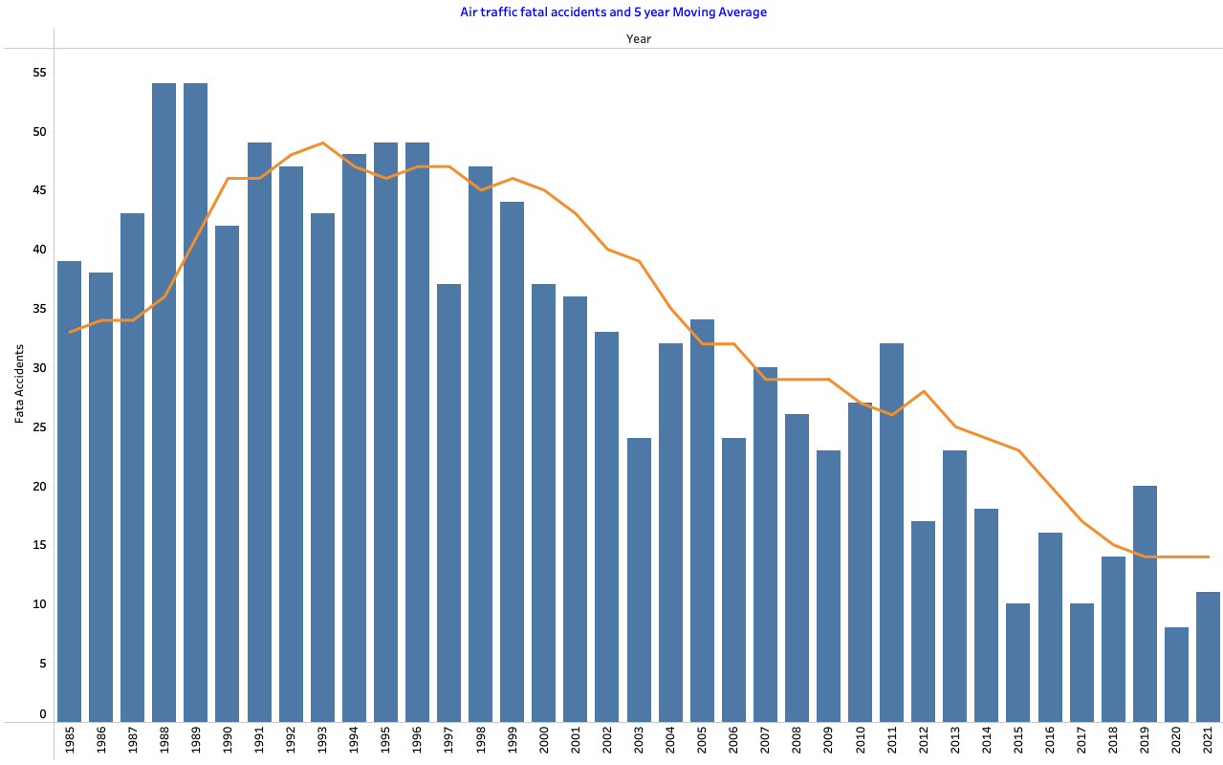

Conclusion
Based on the about analysis, in this blog we could conclude few things Based on the analysis, it is clear that air travel is much safer mode of transportation:
- Airline travel is still safest way of travel.
- There is no impact on net profit and public demand of air travel is increasing and will improve sales.
- For all passengers the government regulation on seats on an airplane have met strict standards for head-impact safety and durability.
- You are nineteen times safer in a plane than in a car.
- Air travel resulted in 0.07 deaths for every 1 billion miles travelled compared to 212.57 for motorcycles and 7.28 for cars.
References:
- https://www.blogger.com/about/
- https://karthikchellamuthu.blogspot.com/
- https://www.internationalinsurance.com/advice/fly-safe.php
- https://cdan.dot.gov/SASStoredProcess/guest
- https://www.airlines.org/dataset/world-airlines-traffic-and-capacity-2/
- https://www.statista.com/statistics/263443/worldwide-air-traffic-fatalities/#professional
- https://docs.google.com/spreadsheets/d/1SDp7p1y6m7N5xD5_fpOkYOrJvd68V7iy6etXy2cetb8/edit#gid=1448957446

